**Bus Parking**

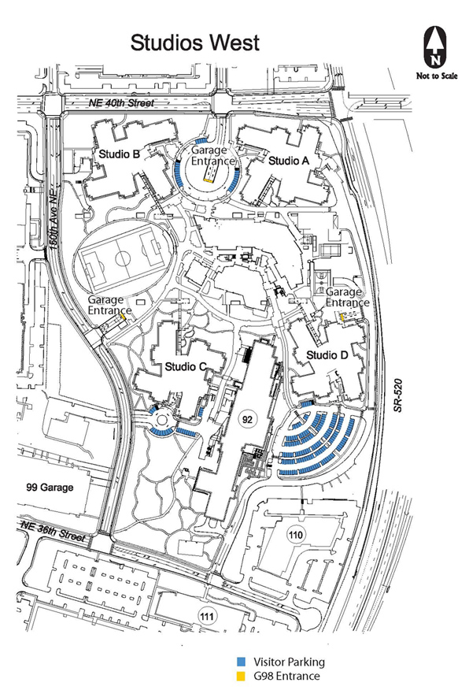

**Parking Areas**